3.7/3.8 Assessment Write up

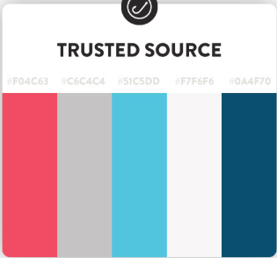The initial planning phase helped develop an idea for the style of my GUI as through researching other websites that offered the same service I discovered that a simple UI was used. Furthermore, through research of other sites I discovered that most sites started off the website with a date select and therefore I decided to implement the same and used a step by step form which worked well with the date select and the ability to select cars.

Using my research of other sites, I found that a white or off-white background worked well with a nice vibrant colour and therefore I decided to implement a similar colour scheme. I used the off-white colour (#F7F6F6) as a background for my site with the red colour (#F04C63) as the vibrant red pop of colour. This worked well with the aesthetics of my site as feedback from using the website shows that this colour scheme worked well as a user commented “The aesthetics are nice on the eyes and comfortable.”

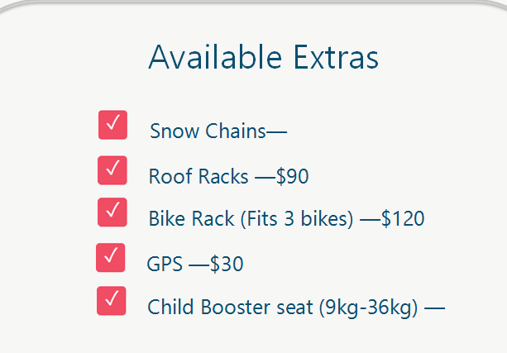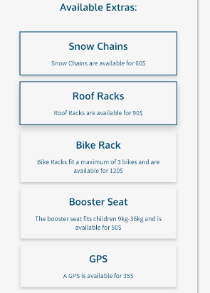Through user feedback and testing of my website I was able to beneficially change some of the UI elements. In my initial wireframe I used a series of checkboxes for the user to select extras however after feedback on how this could be improved I went for a more simplistic card selection choice. These changes helped improve the aesthetics of the website and improved the usability of the site as large cards are much easier to select, especially on smaller mobile devices. Furthermore, the cards better fit the aesthetics of the site as other tabs of the step by step form used cards and thus it kept with the consistency of the site.

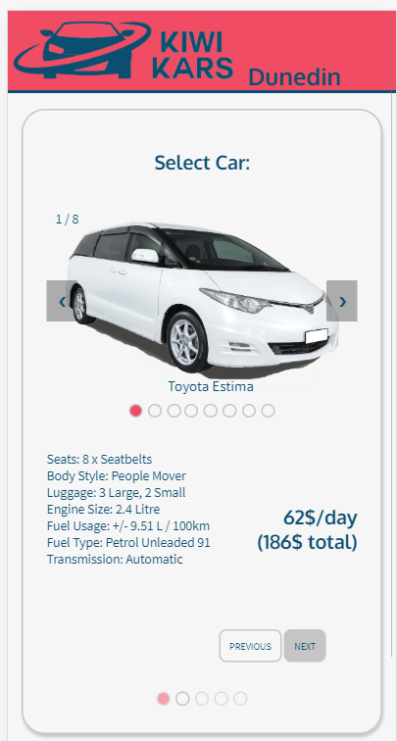

One of the concerns a user raised while testing was that the site was “not so scaleable” which went against the usability implication that I had designed for. In order to improve the scaleability of the website I added a slideshow element to the car select page this meant that on smaller lower resolution devices the website would automatically show the slideshow for the user to select the car with. This has the benefits of the user more clearly being able to see the car they are selecting but also allows the car’s information to be displayed on the screen without the need for scrolling. This improved the usability and the scaling of the website making it a mobile friendly site.

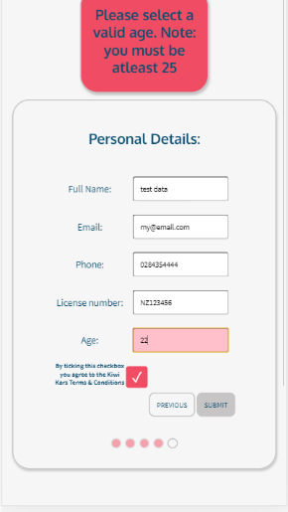In order to improve the functionality of the site I decided to add patterns and minimum/maximum values for the input fields of the site. This was done using html pattern attributes to the input tags. For example the html tag <input type="text" class="detailInput" id="NameInput" placeholder="Your name" pattern="^(\w\w+)\s(\w+)$" autocomplete="name"> uses the pattern attribute with a Regular Expression to ensure that a user enters both a first and last name in the input field. This is then checked to ensure that the data is valid before pushing to the firebase database. In addition if invalid data is given the user is given a friendly error related to the incorrect field and the background color changes to show that the field is incorrect.

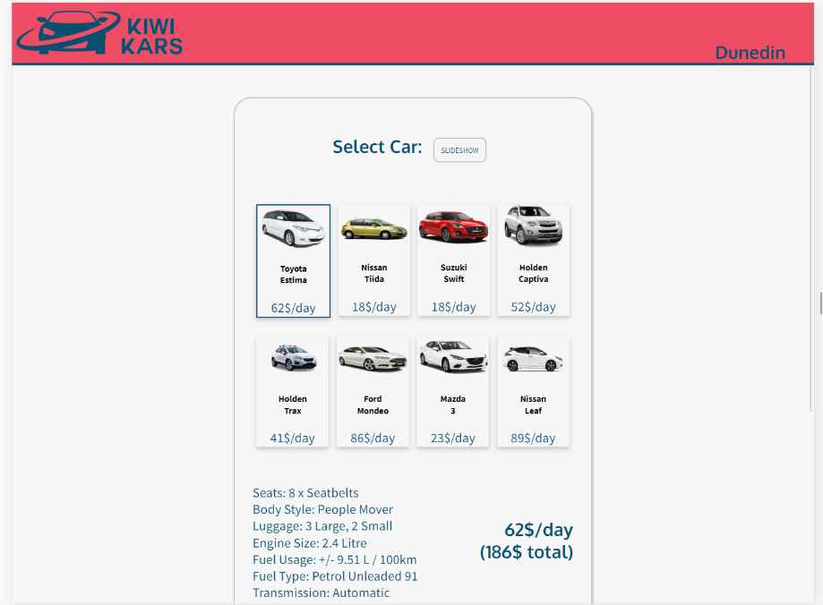The site that I developed addresses the aesthetics implication as it uses a modern style in the form a step by step form along with image slideshows and cards to make the site appealing and attractive. Furthermore, all the inputs are consistently styled and large cards are used to keep the site simple.